**definition**

intact_nlcd - A dataset that that expresses all lands that have not been 81 or 82 for years of analysis (1992-2011).

**Intact_nlcd versions**

V1---

Crop: 81 and 82

Removed all 0 values from reclass

logic

V2----

Crop:82 only

Removed all 0 values from reclass

logic

V3----

~~Crop: 81 and 82 and the specific other classes for 1992!!~~

~~Removed all 0 values from reclass~~ don’t need to do this version --- see logic below

logic

**Exploring unique classes in 1992 nlcd relative to other nlcds**

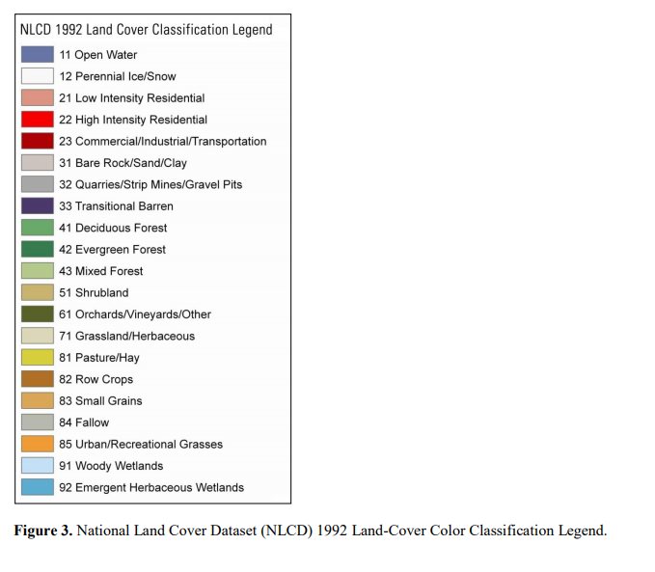

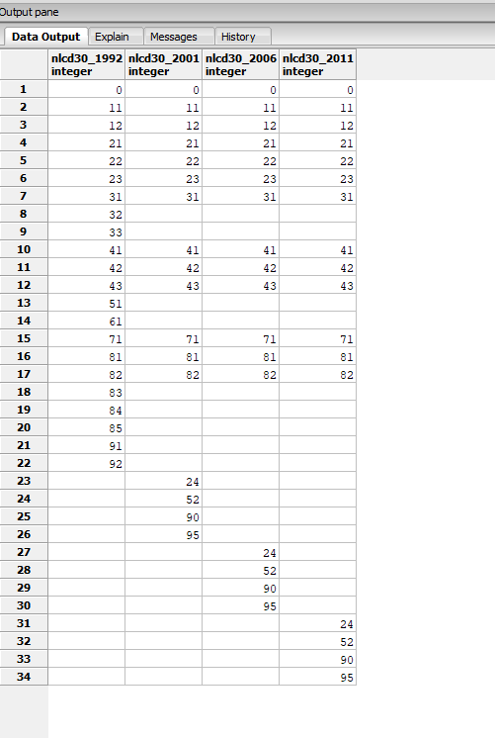

Dataset comparing and contrasting nlcd datasets

Results: All datasets except 1992 have the SAME values

**Included in 1992 only:**

32: Quarries, strip mines/gravel pits --nc

33: Transition barren --nc

51: shrubland --nc

61: orchards/vineyards --c

83: small grain --c

84: fallow --c

85: urban recreation grasses --nc

91: woody wetland -- nc

92: emergent herbaceous wetland --nc

**Included in other nlcd’s only**

24: developed high density --nc

52: shrub/scrub --nc

90: woody wetlands --nc

95: emergent herbaceous wetlands --nc

**Class 61,83,84**

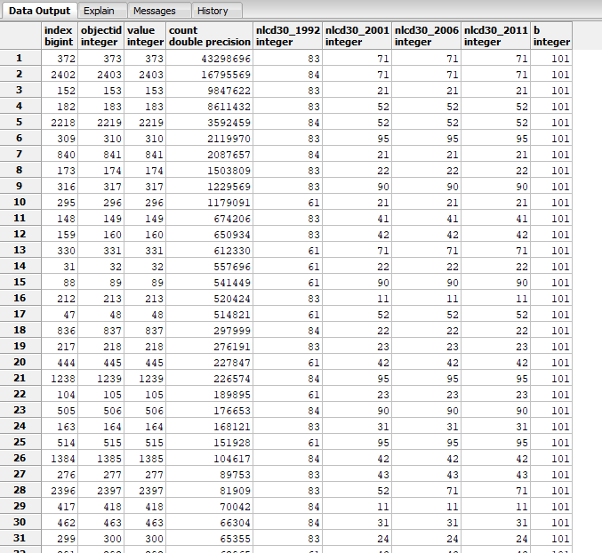

Logic:

Keep classes 61,83,84 as noncrop because the largest records are relabeled grassland(71)or shrubland(52) in the following nlcds. Assume a labeling conversion and not landscape conversion. Very quick inspection with NAIP imagery confirmed this

Refinement

Applied masks to nlcd_